Project Planning Phase
Project Planning Template (Product Backlog, Sprint Planning, Stories, Story Points)

Date | 03 October 2026
Team ID | [Enter Team ID]
Project Name | Auto Ticket Classification Using Flow Designer
Maximum Marks | 5 Marks

Product Backlog, Sprint Schedule, and Estimation (4 Marks)
Backlog items below reflect the actual ServiceNow build: the Update Set, the custom Incident WorkFlow table, the Flow Designer trigger, the If/Else-If classification branches, and the Send Email notification.
Sprint | Functional Requirement (Epic) | User Story Number | User Story / Task | Story Points | Priority | Team Members
Sprint-1 | Environment Setup | USN-1 | As an admin, I can create and activate an Update Set ("Project Update Set") so that all customizations for this project are tracked together. | 1 | High
Sprint-1 |  | USN-2 | As an admin, I can create a custom "Incident WorkFlow" table (u_incident_workflow) with fields Number, Caller, Category, Subcategory, Short Description, Description, State, Assigned Group and Assigned to. | 3 | High
Sprint-1 | Ticket Intake | USN-3 | As a user, I can submit a new IT ticket (e.g., INC0001017) by filling in category, subcategory and a short description of my issue. | 2 | High
Sprint-1 | Flow Trigger | USN-4 | As an admin, I can configure a Flow Designer trigger ("Incident WorkFlow Created") so the flow runs automatically whenever a new ticket record is inserted. | 2 | High
Sprint-2 | Automated Classification Logic | USN-5 | As a system, I can evaluate If "Short Description is Wi-Fi or Network" and update the record's Category to Network. | 2 | High
Sprint-2 |  | USN-6 | As a system, I can evaluate Else If "Short Description is Projector or Hardware" and update the record's Category to Hardware. | 2 | High
Sprint-2 |  | USN-7 | As a system, I can evaluate Else If "Short Description is Forgot Password" and update the record's Category to Access / Password. | 2 | Medium
Sprint-2 |  | USN-8 | As a system, I can evaluate Else If "Short Description is Performance" and update the record's Category to Performance. | 2 | Medium
Sprint-2 |  | USN-9 | As a system, I can add a final Else branch so unmatched tickets are classified as General IT Support instead of being left blank. | 1 | Low
Sprint-2 | Notification | USN-10 | As a support agent, I receive an email (Send Email action) once the flow finishes evaluating a ticket, so I know it has been processed. | 3 | High
Sprint-2 | Testing & Validation | USN-11 | As an admin, I can run Test Flow on sample Incident WorkFlow records and review Execution Details (trigger, flow logic, core actions) to confirm the flow behaves correctly. | 3 | High

Project Tracker, Velocity & Burndown Chart (4 Marks)
Sprint | Total Story Points | Duration | Sprint Start Date | Sprint End Date (Planned) | Story Points Completed | Sprint Release Date (Actual)
Sprint-1 | 8 | 6 Days | 01 Dec 2025 | 06 Dec 2025 | 8 | 06 Dec 2025
Sprint-2 | 15 | 6 Days | 08 Dec 2025 | 13 Dec 2025 | 15 | 13 Dec 2025

Velocity:
Average Velocity (AV) = Total Story Points Completed ÷ Number of Sprints
Total Story Points Completed = 8 (Sprint-1) + 15 (Sprint-2) = 23
Number of Sprints = 2
Velocity = 23 ÷ 2 = 11.5 Story Points per Sprint
Burndown Chart:
A burndown chart shows work remaining versus time. The chart below tracks story points remaining across both sprints against the ideal pace needed to finish on schedule.
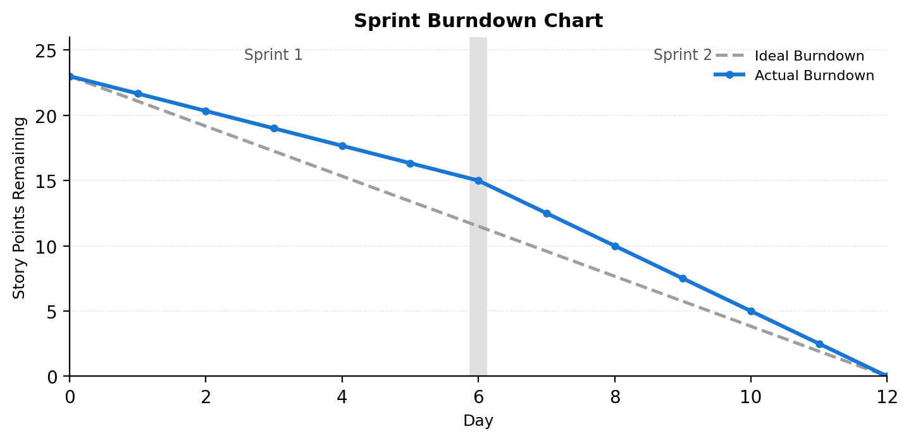
References:
https://www.visual-paradigm.com/scrum/scrum-burndown-chart/
https://www.atlassian.com/agile/tutorials/burndown-charts

